From: https://elpalomitron.com/marisol-de-nina-prodigio-a-actriz-dramatica/

MARISOL: FROM GIRL PRODIGIO TO DRAMATIC ACTRESS
 Javier Valera Posted on29 November, 2019
Next Monday, December 2, the list of nominees for the 34th edition of the Goya Awards that will be held in Malaga on January 25, 2020 will be announced, but there is an award that has already been awarded and that is the Goya of Honor that this year it has been awarded to the singer and actress Marisol (Pepa Flores) . This award is a good excuse to review Pepa Flores' entire professional career in front of the screens, which is comparable to her entire musical career, since her filmography spans from the early 1960s to the mid-1960s. 80s when he retired from public life.
Likewise, the figure of Marisol or Pepa Flores , which is her real name, is associated with the stage of child prodigies like Joselito but we would not be exact if we did not focus our attention on the entire career of this actress who knew how to turn her career around Starting in the early 70's, showing that she had more than enough boards to play leading roles far removed from the prototype of the good girl that the public of the time had accustomed to since she emerged with Un ray de luz in 1961. Because Marisol He has worked with the best directors of the time: from Luis Lucia to Carlos Saura or Juan Antonio Bardemto Mario Camus for which we find ourselves before an actress whose Goya de Honor is more than justified.

His beginnings in the profession
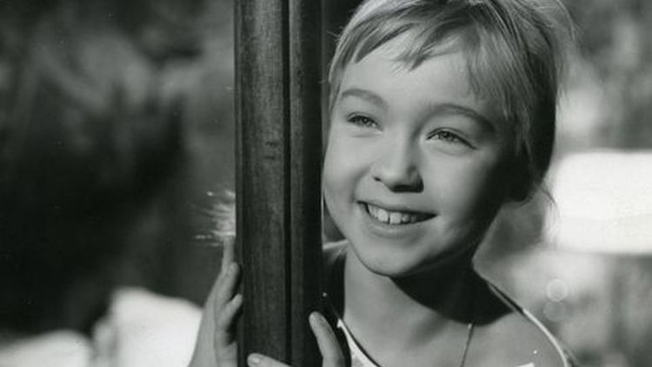
Born in 1948, in Malaga, Marisol learned from a very young age to sing and dance and at the age of eight she began to travel half of Spain when a businessman hired her for his tour. It was his first approach to show business but it would not be until 1959, when he was eleven years old, when he moved to Madrid and stood out on the radio, in one of the many contests that were held at that time, where he was part of a group of the Female Section where she was the soloist. After going to Televisión Española together with the musical group, she was discovered by Luis Lucia and Manuel J. Goyanes, who would become her first representative and with whom she began a whole film career as well as a musical one.
Its premiere on the big screen took place in 1961 with Un rayo de luz , directed by Luis Lucia , a director with whom she would work on several occasions and of whom, according to Marisol herself , does not keep good memories since he had a quite sour character. This film (for which she won the award for best child actress at the Venice Film Festival ) is followed by titles such as An angel has arrived (1961) and Tómbola (1962), both directed by Luis Lucia and where the structure used to be more o less the same: the character that Marisol playedIt was called the same in the film, the plot was at the service of the songs (at that time this type of feature films were made for commercial and advertising purposes to announce the stars of the moment) and it was surrounded by actors of the stature of Isabel Garcés , Carlos Larrañaga , Rafael Alonso or Rafaela Aparicio in the case of Marisol heading to Rio ( Fernando Palacios , 1963).

From girl to teenager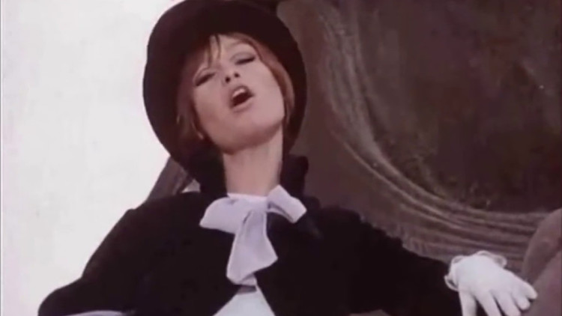
In 1964, Marisol was already 16 years old and logically she could not continue giving the image of a sweet and tender girl that she had reflected in her first films, but her representative, producer and other people were still determined and financially interested in continuing to exploit the product, her product. A child prodigy that her discoverers had designed as they pleased and exploited ad nauseam and so much so that even to prevent her from appearing her age on the screen, they came to bandage her breasts and thus be able to stretch the figure of a girl well that so many commercial successes He had produced more than one, except for the protagonist who received the minimum compared to the millionaire figures that thanks to his image he was able to collect.
Films such as The Welcome Story ( Augusto Fenollar , 1964), The New Cinderella ( George Sherman , 1964) or B Buscame That Girl ( Fernando Palacios , 1964) were released in the same year, another example of how the desire to continue exploiting the The product led to chaining one filming after another, meanwhile all of Spain continued to admire the young girl (or adolescent) Marisol , oblivious to everything that was happening; The actress herself said that, in the filming, if she had to do a dramatic scene and she couldn't cry, they would threaten her saying that if she didn't cry she wouldn't see her mother.
In Cabriola (1965), Marisol was directed by Mel Ferrer who had a reputation for bad character and who at that time was married to Audrey Hepburn, who taught the young woman to put on eye makeup to film. The end of a stage was approaching and films such as Marisol's 4 weddings ( Luis Lucia , 1967) or Solos los dos ( Luis Lucia , 1968) show it: there was no longer any trace (except for the songs) of that angelic girl who she had achieved stardom in the early 1960s. Marisol was already a woman.

From prodigy girl to woman

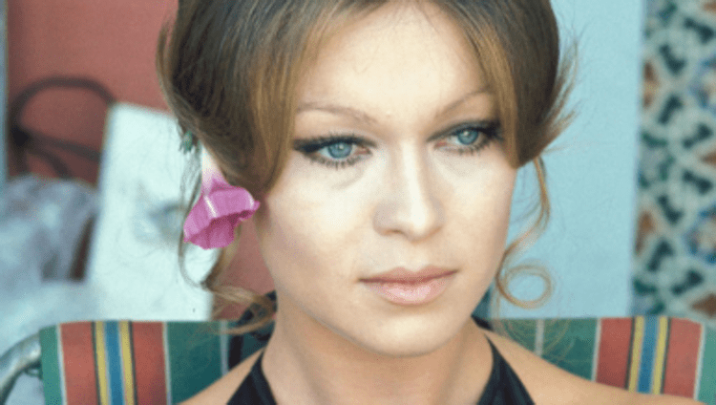
Carola by day, Carola by night (1969) marks a change in the actress's career, despite the fact that she continued with her musical side and the film is accompanied by some of her themes, she has already begun working with more recognized directors within the national scene : this time it was Jaime de Armiñán who directed it and it was the last film produced by its discoverer Manuel J. Goyanes . Although Marisol had grown up, it cannot be said that she received the most interesting project scripts; The only change that this film has, compared to the previous ones, is that Marisol was already 21 years old and the films could already include love plots.
Between 1969 and 1973 there is a break in her cinematographic career but what happened in 1970 cannot be ignored. The actress, advised by her husband Carlos Goyanes who was her representative at that time, agreed to do a nude photo session for a project that Bernardo Bertolucci was carrying out and that would have the leading role of Alain Delon , it would be his first international project but in the end that did not prosper; Of course, the photos were kept in a drawer and Interviú magazine published them at the end of the 70s.
In La chica del Molino Rojo ( Eugenio Martin , 1973), Pepa Flores coincided as the protagonist with Mel Ferrer , who directed her in Cabriola , and she already had the opportunity to start her stage (already separated from the Goyanes and with Paco Gordillo as his representative) of a more dramatic actress, with more in-depth roles, but, for now, they continued to include musical numbers in their films (it is true that it was also their job, that of a singer) although in this film they are totally justified by being set in a kind of cabaret. The film grossed more than 300,000 euros at the time.
With Juan Antonio Bardem, he starred in two films. The corruption of Chris Miller (1973) where he coincided with the actress of the nouvelle vague Jean Seberg in a horror film in which Marisol was able to play a tormented woman bordering on almost madness. We are not facing the director's best stage, but even so, he managed to get more than a million viewers to attend theaters and for Pepa Flores to completely disengage from her musical period in the cinema. In The Power of Desire (1975) Marisol plays another mysterious woman in a film written by Juan Antonio Bardem with Rafael Azconawhich raised more than 500,000 euros. Perhaps this figure is due to the fact that Pepa Flores starred in the occasional erotic scene, as ordered by the uncovering cinema, which was so successful at that time.

Consolidation as a dramatic actress

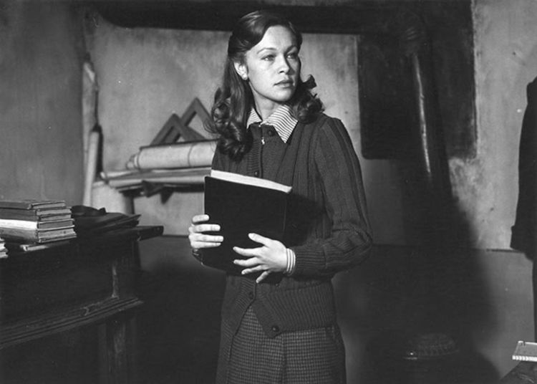
If with Juan Antonio Bardem he managed to develop some dramatic roles far from the usual registers of his films in the 60s, Mario Camus managed in Los Días del Past for Marisol to show that she was a great dramatic actress. At that time she was married to the dancer Antonio Gades who had also been an actor. The affinity that both had with the Communist Party helped Camus decide to grant him the leading roles in the film, it also influenced that he was one of the couples of the moment. The days of the past is set in the Spanish postwar period and, above all, on the theme of the maquis. MarisolShe plays a young woman who travels to a small town in the North of Spain to teach classes but with the aim of finding her husband whom she has not seen for a decade. Through a series of encounters, scarce and fleeting, with her love ( Antonio Gades ) Marisol is able to reflect all the anguish that a woman can feel in those circumstances and she would not do it so badly when she was awarded the award for best actress at the Karlovy Vary International Film Festival . Pepa Flores managed to show all her acting skills, but that didn't help her to carry out many interesting projects in front of the cameras from that moment on.

Latest television and film roles

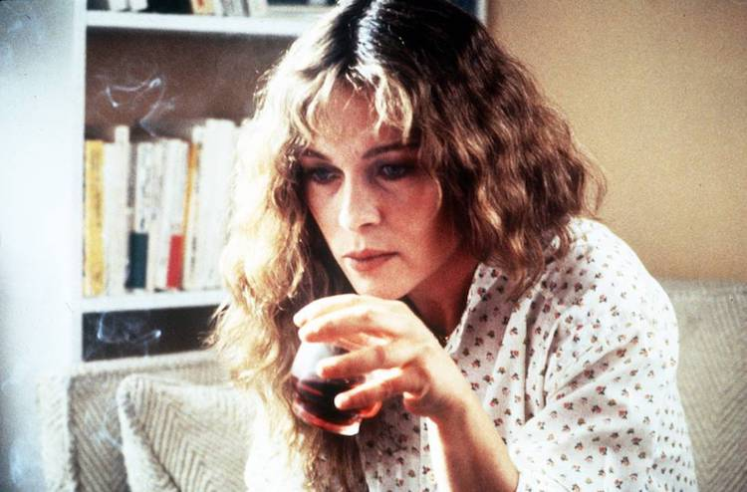
Marisol's relationship with Antonio Gades also favored Carlos Saura to offer her a special collaboration in Blood Wedding , the film that Saura wrote based on the adaptation of a theatrical performance that Gades himself had performed in 1977. In the film, where fiction is mixed with documentaries apart from the flamenco dance that floods the screen during almost the entire film. In one scene, Marisol plays a flamenco lullaby and it is one of the best moments of a film based on the book by Federico García Lorca . Also in the company of Carlos Saura and Antonio Gades ,Marisol appeared in Carmen (the second film of the flamenco trilogy that Saura made during the 80s) where she also plays a flamenco palo with the company, on guitar, by Paco de Lucía .
In 1984 he again approached a text by Federico García Lorca when he agreed to star, for Spanish Television and directed by Rafael Moreno Alba , Proceso a Mariana Pineda , a five-part television miniseries although, it is true, that at that time he was filming series TV in Spain was like shooting movies, it was done exactly the same. It is said that Pepa Flores only accepted this role for economic reasons since her cache was destined to help financially the ballet company of her then husband, Antonio Gades . Journalists who treated her in those years comment that MarisolShe was already very tired of public life and did not want to do any more dramatic roles, she only thought about retiring and dedicating herself to her children.
Therefore, his last appearance in the cinema is in 1985 with Case closed . The director, Juan Caño Arecha , had to convince her to accept the role since he was only thinking of retiring. Finally, she accepted it because the film raised issues that interested her and that she considered ethical to defend, such as "the collusion between Justice, Finance and Police against the individual and freedom . " Marisol was not very happy with the result and at the San Sebastian Film Festival , where the film was presented in the New Directors category, she admitted "that it could have done a thousand times better."
After this film, she decides to withdraw completely from public life, although being retired she has continued to have offers to make movies again, curiously, she got to meet with the producer of Beyond the Garden ( Pedro Olea , 1996) who put her on the table a blank check for her to choose the figure and Marisol only said: "Sir, in life not everything is done for money . " She has not returned to public life, except for an interview that she gave to José Manuel Parada at Cine de Barrio in 2000 where she acknowledged that she felt "a woman like everyone else " and that she had renounced "things that do not serve me.". That artistic silence, which has come to be compared with actresses like Greta Garbo , during these twenty years does not seem to stop even if she is awarded the Goya of Honor in her land, in her beloved Malaga. Marisol is faithful to her words and not appearing before the media, since the Film Academy has confirmed that there will be no press conference, it is one more aspect of her coherence as an artist and if one day she said no, it is almost certain that now it will also be no.
Javier Valera

